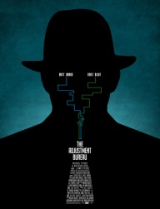
Name ____________________
The Censors, by Luisa Valenzuela
Instructions: Fill in the chart with quotes from the text.
“The Censors” by  Luisa Valenzuela | Description | Text Evidence
Mood | Paranoid, oppressive, fearful
Setting | Clue: What does the job do to people? How does it impact people’s behavior?  Write your description below:
Irony | Clue: What is Juan’s greatest fear? What happens in the end?  Write your example of irony below:  Verbal Irony:
Tone
Characterization | Clue: In your own words, how would you describe Juan?
In sentence, express what you think the story’s theme is. Start your sentence with the word, censorship.

Your Opinion: Is censorship ever appropriate? Why or why not? Use examples to support.

